

SAN-JAN DATA ANALYST AND TECH

Big data for better solution

Version *<1.0>*

*<22/11/2016>*

*Author: Janakiraman*

Table of Contents

1. Project definition 3

1.1 What is BIG DTA 3

1.2 Background 3

1.3 Business Case 3

1.4 Project objectives and desired outcomes 3

1.5 Project outputs 4

1.6 Project scope 4

1.7 Project budget 4

2. E-Commerce 5

2.1 What is E-Commerce 5

2.2 Databases for Transaction details 5

2.3 Databases for Customer details 5

2.4 List of use cses 6

3 Conclusion 10

**Project Definition**

* 1. **what is BIG DATA**

Big data is a term that describes the large volume of data – both structured and unstructured – that inundates a business on a day-to-day basis. But it’s not the amount of data that’s important. It’s what organizations do with the data that matters. Big data can be analysed for insights that lead to better decisions and strategic business moves. Big data is changing the way people within organizations work together. It is creating a culture in which business and IT leaders must join forces to realize value from all data. Insights from big data can enable all employees to make better decisions—deepening customer engagement, optimizing operations, preventing threats and fraud, and capitalizing on new sources of revenue. But escalating demand for insights requires a fundamentally new approach to architecture, tools and practices.

* 1. **Background**

We are provide accurate data solution to the industries who`s generating huge amount data, using various tools and techniques under Big Data technology.

**1.3 Business Case**

Huge amount of data being generated by everything around us at all times. Every digital process and social media exchange produces it. Industries struggling with handle this amount of data. So we made it as a business to give accurate data solution.

**1.4 Project objectives and desired outcomes**

San-Jan Data Analyst and Tech is a MNC (Multi National Company) for data analysis and to provide technology solution to the major industries. We uses various scenarios in Big Data to provide desired outcomes.

Here our current project fully based on E-Commerce, there are tons of transaction process, log files and feedback files created. All Industries struggling to handle these huge volume data generated by the customers. This project specifically for provide clean data solution about E-Commerce.

**1.5 Project outputs**

Our project outputs come with clear documentation along with input and output snapshots, so a non-technical person also can understand the results.

**1.6 Project scope**

Our E-Commerce project scope to provide clear outcomes as per the client`s requirement.

**1.7 Project budget**

We offer less charge depend with volume of data, and for this particular E-Commerce project our offer is very flexible charge for clients.

**E-Commerce**

**2.1 What is E-Commerce?**

E-commerce (electronic commerce or EC) is the buying and selling of goods and services, or the transmitting of funds or data, over an electronic network, primarily the internet. These business transactions occur either as business-to-business, business-to-consumer, consumer-to-consumer or consumer-to-business.

**2.2 Database for Transaction details**

Here is the transaction database for sample.

|  |  |  |  |  |  |  |  |  |
| --- | --- | --- | --- | --- | --- | --- | --- | --- |
| Tid | Date | Cust id | Amount | Category | Product | City | State | Payment mode |
| 00000001 | 06-26-2015 | 4007024 | 040.33 | Exercise & Fitness | Cardio Machine Accessories | Clarksville | Tennessee | credit |
| 00000002 | 06-26-2015 | 4007023 | 238 | Gymnastics | Gymnastics Rings | Des Moines | Iowa | credit |
| 00000005 | 06-26-2015 | 4007028 | 1265 | Outdoor Recreation | Camping & Backpacking & Hiking | Chicago | Illinois | credit |

**2.3 Database for Customer details**

Here is the transaction database for sample.

|  |  |  |  |  |
| --- | --- | --- | --- | --- |
| Custid | Fname | Lname | Age | Profession |
| 4000001 | Sunitha | Devi | 22 | Teacher |
| 4000002 | Arul | Selvan | 25 | mentor |
| 4000003 | Vinod | Kumar | 33 | manager |

**2.4 List of use cases**

Test case 1:

==========================================================================

To get all the details from the transaction amount detail that is greater than with a specific amount which the user wants.

Output file:

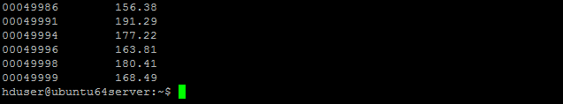

Test case 2:

==========================================================================

To count all the transaction where amount is between 150 and 500.

I/P data:

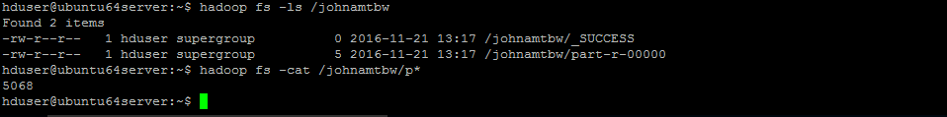

O/p data;

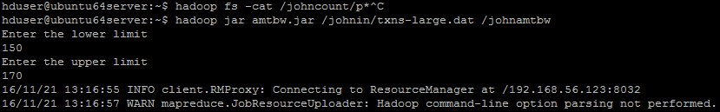

Test case 3:

==========================================================================

Calculate the total sum and total count of all the transaction for each user id.

I/P data:



O/P file

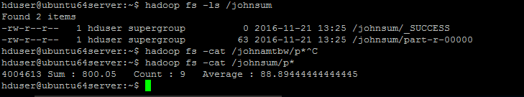

Test case 4:

Calculate total sales amt for each Month.

I/p file:

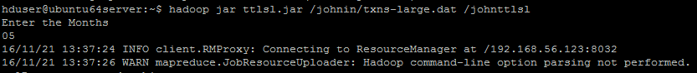

O/p file :

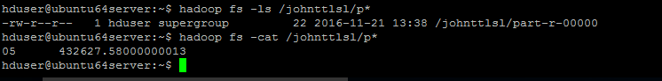

Test case 5:

==========================================================================

Divide the file into 12 files, each file containing each month of data. For eg. file 1 should contain data of january txn, file 2 should contain data of feb txn.

I/p file:

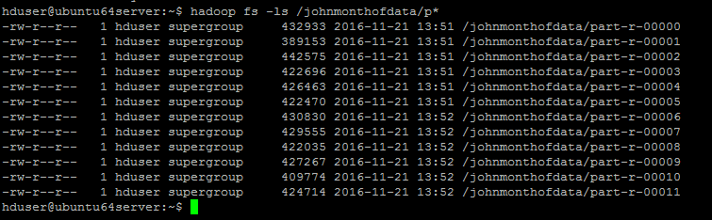

O/p file: 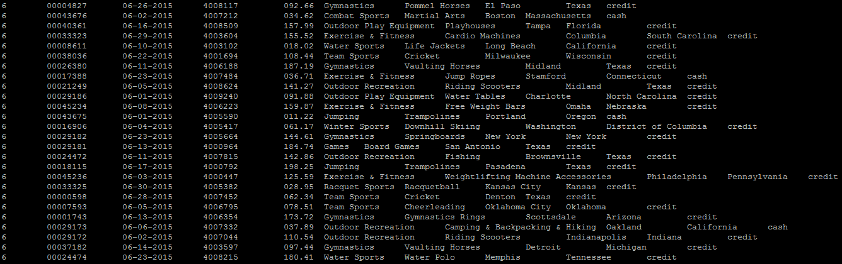

Test case 6:

==========================================================================

Sorting all the transaction amount in ascending order.

O/p file:

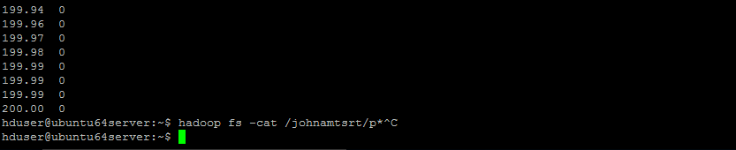

**Conclusion**

With these different scenarios we can give different dimensional solution in accurate with a huge dataset. This type of data solution will help Industries to maintain their customer and transaction details as well. We are very trustable MNC for data solution and we can proudly say, we are the best data analyser and tech solution provider for other MNC`s and start-ups companies who needs data solution.